Rumor Propagation Modeling Using Cell-DEVS
Bahareh Pourahmad
1. Introduction and Motivation
The spread of information and rumors is a common phenomenon in social systems, communication networks, and distributed environments. Individuals interact locally with their neighbors, but these simple local interactions can produce complex global behavior. Studying rumor propagation helps us understand how information moves through a population and how initial conditions affect the speed and pattern of spread.
In this project, rumor propagation is modeled using the Cell-DEVS formalism and implemented in the Cadmium simulation framework. Cell-DEVS is appropriate for this type of problem because it represents the system as a grid of interacting cells, where each cell changes state according to local rules and neighbor influence.
The objective of this work is to simulate rumor propagation in a two-dimensional population grid and analyze the effect of different initial conditions on the propagation process.
2. Conceptual Model Description
The system is represented as a two-dimensional cellular grid. Each cell corresponds to one individual in the population. Individuals interact only with nearby neighbors.
The neighborhood used in this model is the Moore neighborhood, which includes the eight surrounding cells. This means that each individual can be influenced by any adjacent neighbor.
Each cell can be in one of three states:
State | Meaning
0 | Unaware of the rumor
1 | Spreading the rumor
2 | Inactive, no longer spreading
At the beginning of the simulation, only a small number of individuals are initialized as rumor spreaders, while the remaining cells are unaware. During the simulation, rumor spreaders influence nearby unaware individuals, causing the rumor to propagate through the grid.
This conceptual model captures a simplified but meaningful information diffusion process: individuals first receive the rumor, then spread it for some time, and finally become inactive.
3. Formal Cell-DEVS Specification
The rumor propagation model is implemented as a Cell-DEVS system in which each cell evolves according to local transition rules and timing behavior.
Each cell has:
- a state from the set {0, 1, 2},
- a neighborhood defined by surrounding cells,
- a transition function based on the current state and neighbor states,
- an output delay that defines when state updates occur.
The behavior of each cell is defined through the Cell-DEVS functions localComputation and outputDelay.
The transition rules are as follows:
Rule 1: Unaware to Spreader
If a cell is in state 0 and at least one of its neighbors is in state 1, the cell changes to state 1.
Rule 2: Spreader to Inactive
If a cell is in state 1, it changes to state 2 after spreading the rumor.
Rule 3: Inactive Remains Inactive
If a cell is in state 2, it remains in state 2 permanently.
These rules model a simple rumor-spreading mechanism in which information spreads locally and eventually stops when individuals become inactive.
4. Implementation
The model was implemented in C++ using the Cadmium Cell-DEVS framework.
The project includes the following main components:
Folder/File | Purpose
src/ | C++ implementation files
model/ | Model configuration and rule files
logs/ | Simulation output logs
scripts/ | Data processing and visualization scripts
viewer/ | Local visualization files
The main model files are:
- src/rumorCell.hpp, which defines the atomic Cell-DEVS behavior,
- src/rumor_coupled.hpp, which defines the coupled grid model,
- src/main.cpp, which builds and runs the simulation.
The model configuration is defined using JSON files stored in the model/ folder. These files specify the grid size, initial conditions, and neighborhood structure.
The behavior of each cell is implemented using the localComputation function, which updates the cell state according to the transition rules and neighbor states. The outputDelay function controls the timing of state changes.
The simulation generates output files such as:
- logs/state.txt
- logs/output_messages.txt
These files are used later for analysis and visualization.
5. Experimental Setup
To study the behavior of the rumor propagation system, several simulation scenarios were considered.
Experiment 1: Single Rumor Source
In the first experiment, the rumor starts from a single source cell. This scenario shows how the rumor spreads outward from one origin point through local interactions.
Experiment 2: Multiple Rumor Sources
In the second experiment, the rumor starts from multiple cells located in different parts of the grid. This allows observation of how parallel propagation regions accelerate the spread.
Experiment 3: Larger Grid
In the third experiment, the grid size is increased to represent a larger population. This experiment shows how system size influences propagation time and coverage.
These experiments make it possible to compare the propagation dynamics under different initial conditions and population sizes.
6. Simulation Results and Analysis
The simulation results were recorded in the generated log files and visualized using a local viewer and animation tools.
The results show that rumor propagation follows the expected behavior defined by the transition rules.
In the single-source scenario, the rumor spreads outward in a wave-like pattern from the initial source. The active spreading region expands gradually and then becomes inactive behind the propagation front.
In the multiple-source scenario, the rumor spreads significantly faster because several active regions appear simultaneously. This reduces the time required to cover the grid.
In the larger-grid scenario, the overall behavior remains similar, but the propagation requires more simulation steps to reach distant cells because the population is larger.
These results confirm that local interactions between neighboring individuals generate global propagation behavior across the grid.
7. Visualization Results
The model outputs were visualized using a local web-based viewer and generated images from the simulation output.
Three representative stages of the simulation were used to illustrate the propagation process.

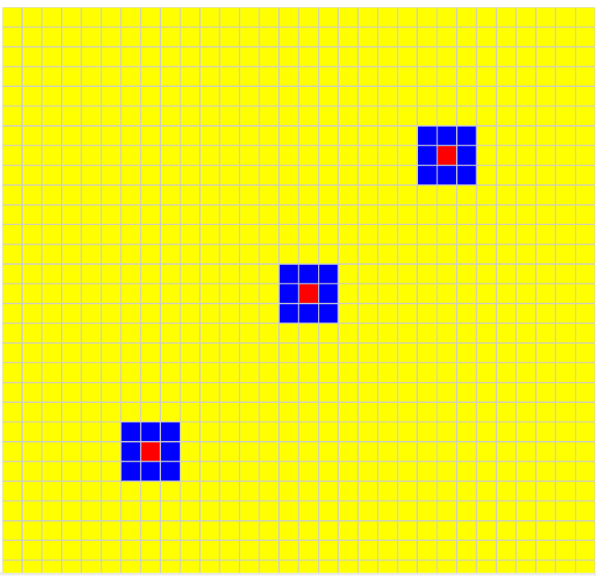
Figure 1: Early stage of rumor propagation. Yellow cells represent unaware individuals, blue cells represent spreaders, and red cells represent inactive individuals. In the early stage, most cells are still unaware of the rumor. A small active front of rumor spreaders appears around the initial rumor sources, and some cells have already become inactive after spreading the rumor.
Caption: Early stage of rumor propagation. Yellow cells represent unaware individuals, blue cells represent active spreaders, and red cells represent inactive individuals.

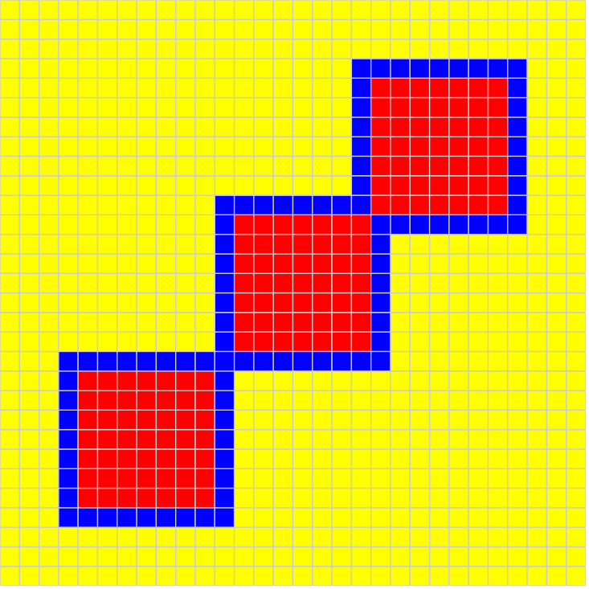

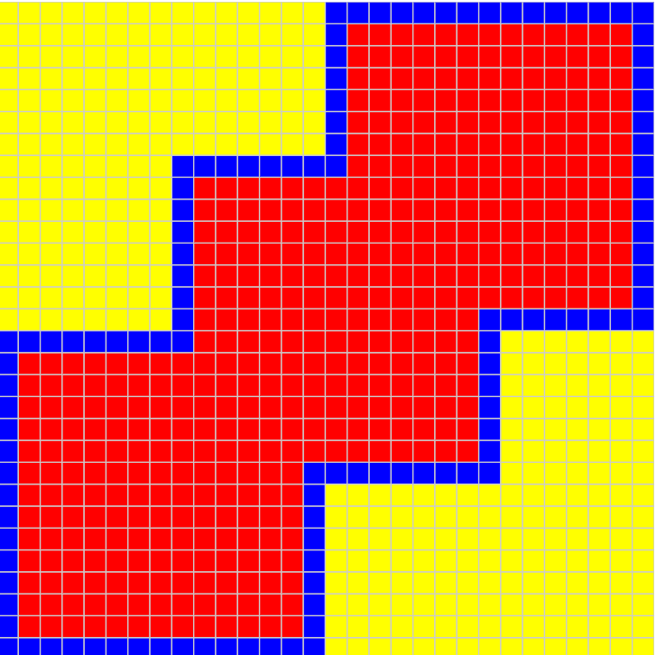
Figure 2. Intermediate Stage of Propagation
In the intermediate stage, the rumor has spread farther across the grid. Multiple propagation regions can be seen, showing how the rumor continues to expand through local interactions.
Caption: Intermediate stage of rumor propagation. The rumor expands from several active fronts, increasing the overall speed of spread.
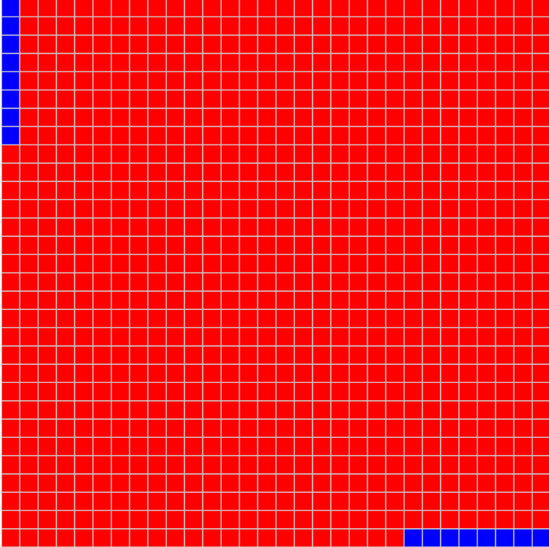

Figure 3. Final Stage of Propagation
In the final stage, most individuals have already received the rumor and become inactive. Only a small number of active spreaders remain, or the spread has nearly completed.
Caption: Final stage of rumor propagation. Most cells have become inactive after receiving and spreading the rumor, indicating near-complete coverage of the grid.
The visualization clearly shows the time evolution of the rumor-spreading process. The state colors make it easy to identify active propagation fronts and final coverage patterns.
The local visualization can be opened at:
http://localhost:8000/viewer/
8. Scripts and Data Processing
Several Python scripts were used to process simulation outputs and generate visual results.
These scripts perform tasks such as:
- converting simulation logs into structured CSV files,
- generating viewer-compatible data files,
- creating animation outputs from the simulation results.
This processing pipeline makes it easier to analyze the simulation behavior and present the results visually.
9. Discussion
The model demonstrates how simple local rules can produce realistic large-scale behavior. Even though each individual cell only reacts to nearby neighbors, the rumor spreads across the entire population in an organized propagation pattern.
The experiments also show that initial conditions strongly influence the system behavior. Increasing the number of initial rumor sources leads to faster spread, while increasing the grid size increases the time required for full propagation.
This confirms that Cell-DEVS is a suitable formalism for modeling distributed dynamic systems with local interactions.
10. Conclusion
This project presented a Cell-DEVS model of rumor propagation implemented in Cadmium.
The model successfully represents a population as a two-dimensional grid of interacting individuals and simulates rumor spreading through local neighborhood influence. The results show that the number of initial rumor sources and the grid size both affect the speed and pattern of propagation.
The simulation outputs and visualizations confirm that the model behaves according to the defined transition rules. Overall, this work demonstrates that Cell-DEVS provides an effective and flexible approach for studying rumor propagation and other information diffusion processes.
11. Files Included in the Submission
The submission includes:
- source code for the atomic and coupled models,
- model configuration files,
- scripts for execution and visualization,
- log files showing execution results,
- local visualization files,
- generated figures and animation results,
- the final report.

